Return-to-Practice Office Manual
  - Adapting the Dental Office to the COVID-19 Pandemic
Phase IV Effective June 12, 2002
Elective Dental Procedures – Dental Hygiene

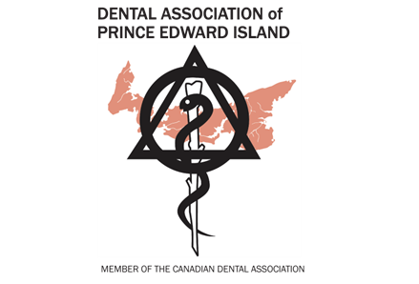

Version 2.1
June 12, 2020
Table of Contents
INTRODUCTION 1
Public Health, Outbreak Level and Dentistry 1
Infection Control 1
OFFICE PREPARATION 2
Reception and waiting area 2
Clinical Areas 2
Common staff areas 3
Receiving deliveries 3
STAFF PREPARATION 3
Daily Screening – Dentists and Staff 3
Hand Hygiene 3
Splatter and Aerosols 4
Table 1: Dental devices and procedures known to produce airborne contamination 5
Personal Protective Equipment (PPE) 5
Table 2: Use of Personal Protective Equipment (PPE) for Coronavirus Disease 2019 (COVID-19)* 6
Table 3: Air changes/hour (ACH) and time required for airborne-contaminant removal by efficiency 7
BEFORE THE APPOINTMENT 8
Determining Patient COVID-19 Risk 8
Table 4: COVID-19 Risk Level from Screening Questionnaire 8
Vulnerable Patients 9
DURING THE APPOINTMENT 9
CLINICAL PRACTICES AND PROTOCOLS 10
Figure 1: Professional Judgement in Treatment Approach Considerations 10
Sample Decision Trees 10
Decision Tree 1: Scheduled Restorative/Endodontic Appointment 11
Decision Tree 2: Routine Hygiene Appointment 12
Emergent vs. Urgent vs. Elective Care 13
Table 5: Medical and dental terminology 13
Non-Aerosol Generating Procedures (NAGP) and Aerosol Generating Procedures (AGP) 14
Appendix 2: Glossary of Terms and Acronyms 20
RESOURCES 22
Patient Screening Form 23
READ BEFORE ENTERING CLINIC 23
Patient Acknowledgement COVID-19 Pandemic Emergency Dental Risk 23
Return to Practice Checklist 23

INTRODUCTION
In March 2020, dental offices across Canada stopped providing oral health treatments and services except for emergency care with the arrival of the novel coronavirus SARS-CoV-2 and the illness it causes, COVID-19. As the pandemic becomes contained and dental offices will be authorized to re-open in a staged manner, measures must be taken to protect patients, dental office staff, dentists and the community at large from the transmission of the coronavirus.

This document provides considerations for PEI dental offices, specific to the COVID-19 pandemic and the level of impact it has had here. It is designed for use by our dentists and the dental team and should be read in conjunction with relevant provincial regulations and policies. It will differ from some other provinces who have had a much higher incidence of Coronovirus cases.

The document is informed by the best available scientific evidence and expert opinion available at this time and is subject to revision as additional information and data becomes available. Where evidence is lacking, recommendations err on the side of caution. As new evidence becomes available, the document will be updated accordingly.
Public Health, Outbreak Level and Dentistry
When an outbreak such as the 2020 pandemic occurs, public health officials (typically the provincial chief medical officer) classify the outbreak in stages or levels, and each stage or level will have different measures aimed at controlling the outbreak. As the outbreak comes under control, the declared outbreak level changes, and the control measures change. Sometimes there is a resurgence of an outbreak, and public health will go back to stricter measures.

During an outbreak, as part of the containment measures used by public health officials, the practise of dentistry may be restricted. The exact restrictions may change depending on the outbreak level as declared by public health officers. They also depend on the nature of the outbreak—how the sickness is transmitted, the severity of the illness, etc.

The information that follows is a general guide to current adjustments to the practise of dentistry based on current knowledge of the COVID-19 pandemic. The modifications to dentistry may change depending on the outbreak level in your community/region/province. Since outbreaks can be quite local, the modifications may be for one different community compared to another community. How dentistry is modified will depend on many factors, and you can expect changes as the level of outbreak changes, as declared by public health officials.

Infection Control
All current Infection Control and Sterilization Guidelines are still in effect
All the modifications for dentistry are based on reducing the risk of spreading infection—from pre-appointment triage to physical distancing to personal protective equipment (PPE). The COVID-19 illness is especially challenging because infected people may not have any symptoms and do not know they are infected. For this reason, infection control measures must be followed in full because each works together with the others to reduce the risk of the spread of infection. Again – Screening is the most important part of the entire process.

The infection control measures are presented as follows:
- Office preparation
- Staff preparation
- Before the appointment
- During the appointment
- Clinical practices and protocols
OFFICE PREPARATION
The following protocols should be observed until public health officials declare physical distancing and other measures are no longer required. Patients and all staff should consider wearing level 1 or 2 masks if there is any problem maintaining physical distancing while moving about and carrying on activities within the office. If it is found to be difficult to do so there are too many people in the facility.
Reception and waiting area
Minimize contact at reception.
  - Maintain physical distancing. 2 metres or 6 feet separation.
  - Consider adding a plexiglass screen for reception or encourage physical distancing with furniture, etc.
  - If one patient is paying for services, can another patient enter the clinical area and still maintain physical distancing?
  - Focus patient activity at the front desk to a limited area. Disinfect the area after patient contact.
  - Consider limiting the number of patients that are in the waiting room at one time
  - Create an area for patient screening/temperature taking/hand sanitizing
- Discourage staff sharing. Do not share pens, phone headsets, staplers, etc.
- Remove fabric surfaces. For cloth chairs in the waiting room, an appropriate barrier covering is an option.
- Promote physical distancing. Reduce seating in the waiting area, ideally chairs are two metres (2m) apart.
- Remove unnecessary items. Remove magazines, brochures, toys, etc.
- Consider posting notices. Promote hand hygiene, physical distancing and cough etiquette.
- Clean and disinfect. Clean surfaces with detergent or soap & water prior to initial disinfection. Disinfect touch surfaces at least twice daily, including chairs, tables, door handles, light switches, clothes hangers, bathroom countertops and fixtures, staff-room surfaces, lab areas, etc.
- Minimize the number of people at the office. Only child and infirm patients to be accompanied.
- Update contacts. Know how to contact the local health department.
- Prepare washrooms. Post hand-washing instructions, ensure adequate supply of soap and disposable towels, make a trash can available.
Clinical Areas
- Sterilization room to be cleaned regularly.
- Follow IPAC regulations and manufacturers’ instructions for testing sterilizers after a prolonged time out of service.
- Shock your dental unit water lines if you are returning from an extended break in practice. Consult the manufacturer’s instructions for proper product recommendations.
- Only patients and necessary attendants allowed in clinical areas.
Common staff areas
Encourage physical distancing. If not possible consider wearing face masks
- Disinfect touch surfaces often.

Receiving deliveries
Minimize transmission risk with procedures such as:
- Wear gloves when collecting and/or accepting mail or packages.
- Wipe entirely the exterior of every box delivered with a paper towel and soap & water solution or sanitizing wipe depending on your supplies.
- Boxes remain untouched for 15 minutes prior to being opened.
- Clean all surfaces that were touched by deliveries with soap and water mix or sanitizing wipes.

STAFF PREPARATION
The post-COVID-19 office is not the same as the pre-COVID-19 dental office. Staff need to understand the risk of infection and disease and feel that they are working in an environment that is safe. Until the pandemic recedes, effective therapy is available, or a vaccine is developed and administered to the vast majority of the population, COVID-19 remains a risk for everyone, especially vulnerable populations. The dental office has changed, and dental office staff should be prepared to adopt infection prevention measures wholeheartedly.

Dentists and Staff
The health of the dentists and staff is paramount and must be monitored for the continued health of the dental team and patients. Daily dentist and staff reminders on this principle and including commitment from all staff to stay at home if have a temperature or are exhibiting any symptoms at all.

Hand Hygiene
Strict staff hand hygiene is of paramount importance. Staff must wash or disinfect hands thoroughly:
- Upon entry into the dental office.
- Before and after any contact with patients, or donning or doffing gloves.
- After contact with contaminated surfaces or equipment.
- In between procedures and after removing PPE depending on the procedure, following established PPE protocols.
Splatter and Aerosols
Dentistry is potentially challenged in infection control because so many procedures create splatter and aerosols. Splatter is made of larger particles and droplets that fall quite quickly. Aerosols are tiny droplets and particles that can float in the air for a long time. Eventually, these tiny droplets settle or are cleared from the air; the time settling or clearing takes depends on the ventilation of the office.
Splatter
Controlling splatter, particularly splatter that includes saliva, is probably most important in preventing COVID-19 transmission in the dental office. Credible scientific evidence shows that SARS-CoV-2 is very contagious with droplets. Uncontrolled splatter “gets everywhere” – on the patient’s face and clothes, on the dentist’s or hygienist’s face, hands, sleeves, clothing and on the floor. This splatter is easily transported, especially on clothing, to other areas of the office, including the washroom, the front desk, the break room, etc. This is one way the virus spreads and infects people. Evidence is beginning to show that heath care workers are becoming infected not in the procedure room, but outside of the procedure room. In addition to goggles, mask and gloves, a face shield is needed, sleeves must be tucked into gloves. Use a gown for appointments with AGP and if the COVID-19 risk of the patient is more than low risk (more on Personal Protective Equipment (PPE) below). During the COVID-19 pandemic, splatter must be minimized through the choice of procedures, and any splatter must be controlled with high volume evacuation (HVE) and careful handling of splattered PPE, clothing and surfaces. Absolute care is needed to ensure any splatter is not carried outside the procedure area. Splatter is the most common infectious risk in the dental office with an infectious virus.
“Splatter is the most common infectious risk in the dental office.”
Aerosol Generating Procedures (AGPs)
Dental aerosols are generated with many procedures, as shown in Table 1. Aerosols that may contain SARS-Cov-2 from an infected patient occur when saliva is aerosolized along with products of the procedure. This occurs with ultrasonic scaling and other aerosol procedures where the saliva cannot be prevented from entering the procedure area and becoming aerosolized. Some studies are showing that the virus may not stay infective in very small aerosol particles and any procedure can be done with a fair level of security if proper screening processes are followed along with HVE

For many procedures, potentially infectious aerosols can be virtually eliminated as follows:
- Have the patient rinse with hydrogen peroxide (H₂O₂) or a sodium hypochlorite solution—this will reduce viruses in the mouth.
- Apply a sealed rubber dam to isolate the procedure area.
- Soak the exposed procedure area with H₂O₂ prior to beginning treatment.
- Any time an aerosol is created in any manner 95% of it can be eliminated with HVE Suction
NOTE - IMPORTANT DURING USE of HIGH-SPEED Hand Pieces

When the treatment proceeds with use of high- speed handpieces and other aerosolizing procedures, the aerosols created will only contain tooth debris and no infectious saliva, minimizing the risk of infectious aerosols. This management combined with 4-handed dentistry using HVE will minimize risk of infectious aerosols, and is expected to be suitable for patients in the low risk category for COVID-19. Research is currently underway to quantify the risks of this approach.

Table 1: Dental devices and procedures known to produce airborne contamination
Device and/or procedure | Contamination
Ultrasonic and Sonic Scalers | Considered the greatest source of aerosol contamination; use of a high-volume evacuator will reduce the airborne contamination by more than 95%
Air Polishing | Bacterial counts indicate that airborne contamination is nearly equal to that of ultra-sonic scalers; available suction devices will reduce airborne contamination by more than 95%
Air-Water Syringe | Bacterial counts indicate that airborne contamination is nearly equal to that of ultra-sonic scalers; high-volume evacuator will reduce airborne bacteria by nearly 99%
Tooth Preparation with Air Turbine Handpiece | Minimal airborne contamination if a rubber dam is used
Tooth Preparation with Air Abrasion | Bacterial contamination is unknown; extensive contamination with abrasive particles has been shown
From: Harrel SK, Molinari J. Aerosols and splatter in dentistry: A brief review of the literature and infection control implications. J Am Dent Assoc. 2004;135:429–437. https://jada.ada.org/article/S0002-8177(14)61227-7/pdf

Clothing and Office Environment
In the highly infective COVID-19 environment, all dental office staff should consider wearing scrubs at work. Scrubs and shoes should be only worn in the office and should be put on when entering the office at the start of the day and removed at the office at the end of the day. In addition:
- Movement between the clinical area and the front office should be minimized.
- In the clinical areas:
  - Keep surfaces clear of items as much as possible.
  - Cover keyboards, computer mice, etc., with clear plastic barriers and change between patients.
  - Minimize paperwork. Cover paper charts with clear barriers.
Personal Protective Equipment (PPE)
Personal Protective Equipment (PPE) is a key line of defense for dental office staff in preventing infection. In a pandemic environment, all dental office staff should be using the appropriate PPE. The necessary PPE is indicated by the provincial dental regulator, and it is based on the dental care being provided, or function in the dental office (e.g. reception, room cleaning, etc.). It is also based on the risk level for the patient as determined by the pre-appointment and appointment arrival screening questionnaires. Table 2 provides a general guide for PPE in the dental office. There may be differences in your province.
Table 2: Use of Personal Protective Equipment (PPE) for Coronavirus Disease 2019 (COVID-19)*
Setting | Staff or Patients | Procedure/Activity | Suggested PPE
Patient room | Dentist/  Assistant/  Hygienist | Low risk  Non-aerosol-generating procedures (NAGP) | - Level 2 or 3 mask  - Face shield or googles  - Scrubs  - Gloves  - Gown if contact with patient or splatter.
 |  | Intermediate and High risk  Aerosol-generating procedures (AGP) with rubber dam | - N95 or equivalent respirator (fitted) OR Level 3 mask  - Face shield or googles  - Cap/bouffant  - Gown  - Gloves
 | Disinfecting treatment rooms for non-aerosol-generating procedures (NAGP) | Can disinfect immediately | - Level 1 mask minimum  - Eye protection  - Gloves
 | Disinfecting treatment rooms for AGP with no suction or rubber dam. High Risk or Positive Patient | Wait to disinfect – follow provincial regulations – ACH a factor only for Positive or High Risk Patients | - Level 1 mask minimum  - Eye protection  - Gloves
Reception | Front office staff | Arrival screening | - Level 1 mask minimum  - Eye protection  - Gloves  - Scrubs
* Adapted from World Health Organization. “Rational use of Personal Protective Equipment for Coronavirus Disease 2019 (COVID-19).” February 27th, 2020: 1-7; and College of Dental Surgeons of Saskatchewan. “CDSS Alert – COVID-19 Pandemic: IPC Interim Protocol Update, April 27th, 2020.”

Notes about Masks
- N95 masks are available in commercial (or standard or non-medical) grade and medical (or surgical or procedure) grade. Medical masks meet requirements for fluid resistance. See Government of Canada, Optimizing the use of masks and respirators during the COVID-19 outbreak, https://www.canada.ca/en/health-canada/services/drugs-health-products/medical-devices/masks-respirators-covid19.html.
- There is evidence a Level 3 mask with a face shield is equivalent to a fitted N95 mask. See: Radonovich LJ Jr, Simberkoff MS, Bessesen MT, Brown AC, Cummings DAT, Gaydos CA, Los JG, Krosche AE, Gibert CL, Gorse GJ, Nyquist AC, Reich NG, Rodriguez-Barradas MC, Price CS, Perl TM. N95 Respirators vs Medical Masks for Preventing Influenza Among Health Care Personnel: A Randomized Clinical Trial. JAMA. 2019 Sep 3;322(9):824-833. doi: 10.1001/jama.2019.11645.
- Counterfeit masks/respirators are an increasing problem. For information on verifying the authenticity of a mask, see: https://www.cdc.gov/niosh/npptl/usernotices/counterfeitResp.html

Remember – Using proper procedures aerosols are minimal or are not contaminated by virus. TO TREAT A COVID-POSITIVE OR HIGH- RISK PATIENT you may want to consider additional air removal if you are at all concerned and want to address the situation for your own peace of mind.
Aerosol contaminants are removed in the following ways:
- They settle out of the air and land on surfaces, including clothing.
- They are evacuated and either removed from the space completely, or the air is HEPA filtered and returned.
- The contaminants are neutralized (e.g. using ultraviolet light).

The ACH in a space can be affected by many factors including the physical layout of the office, the ventilation systems, the height of the ceiling and the presence of windows that can be opened, etc.
ACH in a dental office can be determined by HVAC/ventilation professionals and can be modified, if needed.

However, before making any changes to the dental office, which can be very expensive, refer to the guidance from the provincial regulator on aerosol management. Avoid AGP when possible and reduce aerosols at source with high volume evacuation.

BEFORE THE APPOINTMENT

Before an appointment, the patient must be contacted, and a pre-appointment screening completed. The purpose of the screening is to:
“It’s about knowing who’s in your chair and where they’ve been.”
Dr. Aaron Burry
Canadian Dental Association
- Determine the patient’s risk level for being infected with COVID-19.
- Determine if the patient falls into one of the vulnerable population groups with respect to COVID-19.
- Explain the changed office protocols to the patient.

In this new COVID-19 pandemic environment, patient screening cannot be emphasized enough. You need to ask the right questions to find out if the patient coming to your office may be infected but asymptomatic. It’s about knowing who’s in your chair and where they’ve been.
Determining Patient COVID-19 Risk
Pre-appointment screening or triage is critically important in assessing the risk the patient may have a COVID-19 infection. Screen patients at least twice—one or two days before the appointment and when the patient arrives. Below are typical screening questions to ask the patient before the appointment:
- Do you have a fever or have felt hot or feverish anytime in the last two weeks (14 days)?
- Do you have any of the following symptoms: Dry cough? Shortness of breath? Difficulty breathing? Sore throat? Runny nose?
- Have you experienced a recent loss of smell or taste?
- Have you been in contact with any confirmed COVID-19 positive patients, or persons self-isolating because of a determined risk for COVID-19?
- Have you returned from travel outside of Canada in the last 14 days?
- Have you returned from travel within Canada from a location known affected with COVID-19 in the last 14 days?
- Is your workplace considered high risk? (e.g. routine close contact with many people)

Table 4 shows the risk of a COVID-19 infection based on “yes” answers to the questions above. Additional judgment must be used to carefully each individual and their particular situation.

COVID-19 Risk Level | Screen Questions Answered “Yes”
COVID-19 Positive | Question: 1
Probable Risk | Questions: 2 and/or 3, and 4
Moderate Risk | Questions: one of 5, 6 or 7
Low Risk | Questions: None

If patients with a risk level higher than “low” are treated in the dental office, consider strategies to minimize the risk of infection for other patients. Strategies include:
- Defer appointment for 14 days or more.
- End-of-day appointments for higher risk patients.
- Special treatment days for higher risk patients.
- Fewer appointment times with longer intervals on certain days.

Vulnerable Patients
Some people are more vulnerable to becoming infected and for the infection to become serious. The questions below help assess if a patient is more vulnerable:
- Are you over the age of 60?
- Do you have any of the following: heart disease, lung disease, kidney disease, diabetes or any auto-immune disorder?

The risk of COVID-19 transmission for vulnerable patients can be reduced by scheduling them as first appoint of the day, right after lunch or on separate days.

DURING THE APPOINTMENT

When patients arrive:
- Have patient wash hands (ideally) or disinfect hands with hand sanitizer.
- Consider providing patient with a level 1 mask if the risk of a COVID-19 infection is more than “low.” This is especially pertinent if social distancing is difficult in the dental facility.
- Complete patient arrival screening:
If concerned consider taking patients temperature and record result.
Appointment Arrival Screening Questionnaire.
If patient screening indicates “moderate” or “higher” risk, isolate patient and consult
with dentist and you will probably re-book for 14 days.
- Have patient complete and sign Patient Acknowledgement of COVID-19 Risk Form (see Resources).
- Ask patient to respect physical distancing (6 feet) with all staff and patients.
- Limit patient time in waiting room. Ideally, take the patient to the operatory immediately.

When patient is seated in operatory:
- Chair-side staff don mask before entering operatory.
- No hand-shaking or physical contact.
- Wash hands and don gloves, face shield, etc. in-room.
- Review overall health history, confirming that the screening questions were asked during the check-in procedure, and review if necessary.
- Complete procedures.
- Have the patient don their mask if provided.
- Following proper doffing procedures, remove mask only outside operatory.
- Limit movement out of operatory as much as possible.
- Clean operatory while wearing PPE.

As the patient is leaving:
- Try to have paperwork completed before patient arrives at reception.
- Choose a touchless payment method, if possible.
- After patient leaves, disinfect all patient contact surfaces, including clothes hangers, door knobs, etc.
- Have the patient wash or disinfect their hands before leaving the office.
CLINICAL PRACTICES AND PROTOCOLS
During a pandemic, public health officials will work with the provincial dental regulator to determine what level of dental care may be provided at a given time. At all times, dentists are expected to use their professional judgment based on the particular situation. There are many variables to consider, which change constantly (patient-to-patient, clinic-to-clinic, day-to-day).

Figure 1 illustrates the ongoing need for professional judgment, as is always the case in providing dental care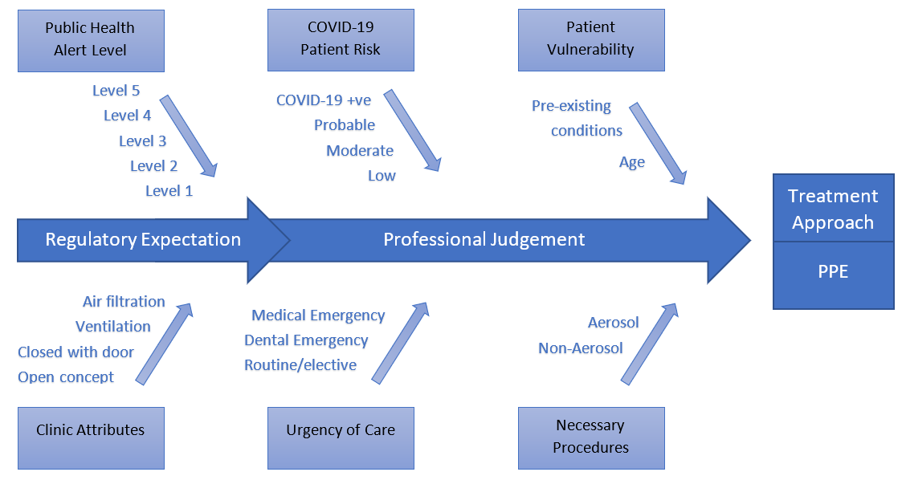

Decision Trees for some standard procedures: Please note an “or” means the protocol has an optional path but with additional requirements. Room settle time would be increased.
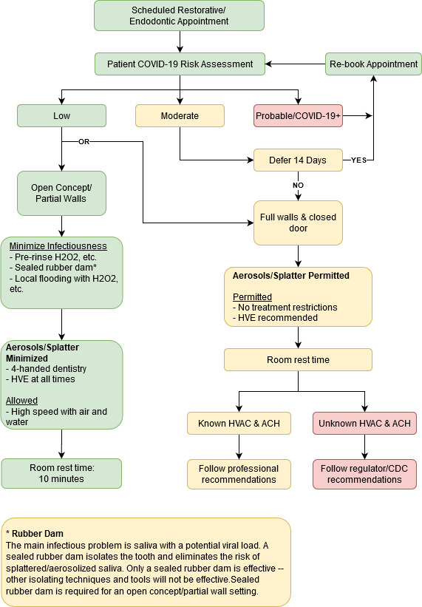

Please note again the “or” is an optional treatment protocol if you want to use Ultrasonic Scalers so a closed room with HVE and additional ACH or HVAC systems to remove and/or filter the air in the operatory. Room settlement time would be longer.

Decision Tree 2: Routine Hygiene Appointment
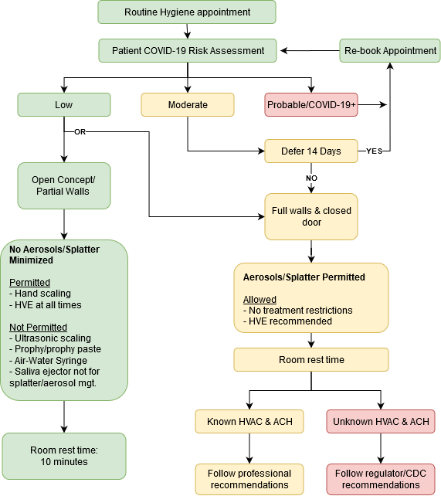
Emergent vs. Urgent vs. Elective Care
The terms “emergent”, “urgent” and “elective” are more typically used in the medical/physician setting, however, during a pandemic with communication from public health officials, these terms become commonplace in dentistry. Table 5 below shows “equivalency” of terms between medical and dental providers.

Table 5: Medical and dental terminology
“Medical” Term | Dental Term
Emergent, Emergency | Medical emergency  Life-threatening emergency
Urgent | Dental emergency  Essential dental care
Elective | Elective  Routine  Non-urgent care

The dental regulator will provide guidance on the definitions of emergent, urgent and elective care. The sample list below is from: RCDSO, Guidance on emergency and urgent care during COVID-19 - Updated April 24, 2020. https://www.rcdso.org/en-ca/rcdso-members/2019-novel-coronavirus/covid-19---guidance-on-emergency-and-urgent-care-

In dentistry, emergency care is provided for a potentially life-threatening condition that requires immediate treatment, including:
- oral-facial trauma
- cellulitis or other significant infection, especially if compromising the patient’s airway
- prolonged bleeding
- pain that cannot be managed by over-the-counter medications

In dentistry, urgent care is the management and treatment of conditions that require immediate attention to relieve pain and/or risk of infection, including:
- severe dental pain from pulpal inflammation
- pericoronitis or third-molar pain
- surgical post-operative osteitis, dry socket dressing changes
- abscess or localized bacterial infection resulting in localized pain and swelling
- tooth fracture resulting in pain, pulp exposure or causing soft tissue trauma
- dental trauma with avulsion/luxation
- final crown/bridge cementation if the temporary restoration is lost, broken or causing gingival irritation
- biopsy of a suspicious oral lesion or abnormal oral tissue
- replacing a temporary filling in an endodontic access opening for patients experiencing pain
- snipping or adjusting an orthodontic wire or appliance piercing or ulcerating the oral mucosa
- treatment required before critical medical procedures can be provided

In dentistry, non-urgent care is the provision of routine or non-urgent procedures, including:
- recall examinations and routine radiographs
- routine dental cleanings and preventive therapies
- orthodontic procedures other than those to address acute issues (e.g. pain, infection, trauma)
- extraction of asymptomatic teeth
- restorative dentistry, including treatment of asymptomatic carious lesions
- cosmetic dental procedures, including teeth whitening
Non-Aerosol Generating Procedures (NAGP) and Aerosol Generating Procedures (AGP)
The provincial dental regulator will provide specific guidance on protocols related to NAGPs and AGPs. General guidelines include:
- Limit AGPs as much as possible
- Limit AGP procedures to a single treatment room or area
- Provide enhanced room cleaning and disinfection
- Have patient complete a pre-procedural rinse with 1% hydrogen peroxide, or similar, for 60 seconds. Have patient spit rinse back into cup provided, not the sink.
- For more on dental aerosols see: Harrel SK, Molinari J. Aerosols and splatter in dentistry: A brief review of the literature and infection control implications. J Am Dent Assoc. 2004;135:429–437. https://jada.ada.org/article/S0002-8177(14)61227-7/pdf.

Appendix 2: Glossary of Terms and Acronyms
ACH means air changes per hour. The movement of a volume of air in a given period of time; if an office has one air change per hour, it means that the air in the office will be replaced in a one-hour period. Adapted from: http://www.caslab.com/Air_Changes_Per_Hour_ACH_Meaning/

AGP means aerosol generating procedures. Aerosol generating procedures are any procedure carried out on a patient that can induce the production of aerosols of various sizes, including droplet nuclei.
Adapted from: http://ipac.vch.ca/Documents/Acute%20Resource%20manual/Aerosol%20Generating%20Medical%20Procedures.pdf

HVAC means heating, ventilation, and air conditioning. Technology related to the indoor temperature and air quality.

HVE means high volume evacuation. A high-volume evacuator is a suction device that draws a large volume of air over a period of time.

Infirm patient means a patient who is physically limited or in ill health. In this context, an infirm patient may need extra assistance to receive dental care, including, but not limited to, moving from one room to another and being physically stabilized in the operatory.

NAGP means non-aerosol generating procedures. Any procedure carried out on a patient that does not produce aerosols.

PPE means personal protective equipment. Equipment worn to minimize exposure to hazards that cause serious injuries and illnesses. In the context of a pandemic, it is equipment worn to prevent transmission of a virus or bacteria.

- N95 or KN95 (fitted): a respirator, which is a particulate-filtering facepiece that can be breathed through, that meets the U.S. National Institute for Occupational Safety and Health N95 classification of air filtration, meaning that it filters at least 95% of airborne particles. To work properly, these masks must be fitted to the wearer. The KN95 is a Chinese equivalent.

- Level 1 or 2 or 3 masks: The American Society for Testing and Materials defines mask levels and which level should be used during different dental procedures. Level 1 masks are considered as a low barrier and designed for procedures with a low amount of fluid, blood, aerosol exposure or spray. Level 2 masks are a moderate barrier. Level 3 masks are considered a high barrier and were designed for procedures with a moderate or high amount of fluid, blood, aerosols or spray exposure, such as implant placement, complex oral surgery, and crown preparation.

- Eye protection (glasses, googles or face shield): safety glasses allow air in and around the eye area while safety goggles fit tight against the face, offering protection against particulate in the air and splashes. Face shields provide further protection, especially from splatter, and can also be worn over spectacles or goggles.

- Scrubs: garments designed to be simple, easy to launder, and cheap to replace. Originally used by surgeons and other operating room personnel, who would put them on during the process of sterilizing themselves before entering the operating room.

- Lab coat (with or without cuff) or gown: a garment intended to be worn by health care personnel during surgical procedures to protect both the patient and health care personnel from the transfer of microorganisms, body fluids, and particulate matter. Cuffs provide greater protection to arms and wrists.

- Cap/bouffant: a loose cap, typically secured around the head with elastic, used to contain hair.

NOTE:
The terms “aerosol” and “splatter” in the dental environment were used by Micik and colleagues in their pioneering work on aerobiology. In these articles, aerosols were defined as particles less than 50 micrometers (μm) in diameter. Particles of this size are small enough to stay airborne for an extended period before they settle on environmental surfaces or enter the respiratory tract. The smaller particles of an aerosol (0.5 to 10 μm in diameter) have the potential to penetrate and lodge in the smaller passages of the lungs and are thought to carry the greatest potential for transmitting infections.

Splatter was defined by Micik and colleagues as airborne particles larger than 50 μm in diameter. Micik and colleagues stated that these particles behaved in a ballistic manner. This means that these particles or droplets are ejected forcibly from the operating site and arc in a trajectory similar to that of a bullet until they contact a surface or fall to the floor. These particles are too large to become suspended in the air and are airborne only briefly.

From: Harrel SK, Molinari J. Aerosols and splatter in dentistry: A brief review of the literature and infection control implications. J Am Dent Assoc. 2004;135:429–437. https://jada.ada.org/article/S0002-8177(14)61227-7/pdf
RESOURCES
The following websites and pages contain several resources that can be printed as stand-alone documents/posters for your dental office.

Additional online resources:
- Government of Canada
Coronavirus disease (COVID-19): Awareness resources
https://www.canada.ca/en/public-health/services/diseases/2019-novel-coronavirus-infection/awareness-resources.html

- Infection Prevention and Control Canada
Coronavirus (COVID-19) Posters, Graphics and Videos
https://ipac-canada.org/posters-graphics-and-videos.php
- Canadian Centre for Occupational Health and Safety
Hand washing and other posters
https://www.ccohs.ca/outbreaks/

Use this form to screen patients before their appointment and when they arrive for their appointment.
Patient Screening Form

Staff screener:
Patient Name: Patient age:
Who answered: ___ Patient ___ Other (specify)
Contact Method: ___ Phone ___ email ___ Other

Identify yourself and explain the purpose of the call, which is to determine whether there are any special considerations for their dental appointment. Have the patient answer the following questions.

Screening Questions | Pre-Screen | In-Office
- Do you have a fever or have felt hot or feverish anytime in the last two weeks?  Patient temperature at appointment: ________. If elevated, provide mask to patient. | YES NO | YES NO
- Do you have any of these symptoms: Dry cough? Shortness of breath? Difficulty breathing? Sore throat? Runny nose? | YES NO | YES NO
- Have you experienced a recent loss of smell or taste? | YES NO | YES NO
- Have you been in contact with any confirmed COVID-19 positive patients, or persons self-isolating because of a determined risk for COVID-19? | YES NO | YES NO
- Have you returned from travel outside of Canada in the last 14 days? | YES NO | YES NO
- Have you returned from travel within Canada from a location known affected with COVID-19? | YES NO | YES NO
- Is your workplace considered high risk? | YES NO | YES NO
Patient Vulnerability
- Are you over the age of 60? | YES NO | YES NO
- Do you have any of the following? Heart disease, lung disease, kidney disease, diabetes or any auto-immune disorder? | YES NO | YES NO

- Any “yes” response for questions 1-7 must be discussed with the managing dentist immediately.
  - Tell the patient when they arrive at the office, they will be asked to: sanitize their hands; answer the questions again; have their temperature taken; complete a form acknowledging the risk of COVID-19.
- Advise the patient:
  - Only patients are allowed to come to the office.
  - If possible to wait in their car until their appointment, call the office when they arrive.
In response to covid-19, additional steps have
been taken to further enhance your safety and
the safety of our staff. Only individuals being treated are allowed to enter the clinic. Accompanying persons are not permitted to enter, with the exception of caregivers.

STOP
READ BEFORE ENTERING CLINIC
Delivery personnel are to contact the facility staff prior to entering.

Please review the following questions to confirm your fitness to enter the facility.
- Do you currently have any of the following symptoms?
- Severe Cough Shortness of breath
- Muscle pains Headache
- Significant Nasal congestion Runny nose
- Fever > 38 Degrees C Reduced or lost sense of smell
- Have you failed to use physical distancing in the last two weeks?
- Have you come into contact with anyone that has any of the above symptoms in the last two weeks?
- Have you come into contact with anyone suspected of having Covid-19 in the last 2 weeks?
- Have you come into contact with anyone diagnosed with COVID-19 in the past 2 weeks?

If you have answered “yes” to any of the above questions,
DO NOT ENTER THE FACILITY.
Call our phone number below and you will be given the appropriate direction.

Only enter the clinic if you answered “No” to all the questions above.

Call us if you have any questions: ( ) .

Patient Acknowledgement COVID-19
Treatment Consent

Please read the patient acknowledgement below, and initial or sign in all areas indicated.

I understand the Federal and Provincial governments have asked individuals to maintain social distancing of a least 2 metres (6 feet) and I recognize it is not possible to maintain this distance while receiving dental treatment. __________ (initial)

I understand that oral surgery/dental procedures can create water and/or blood spray, which is one possible way that the novel coronavirus can spread. . __________ (initial)

I understand that due to the visits of other patients, the characteristics of the novel coronavirus, and the characteristics of dental procedures, that I may have an elevated risk of contracting AND SPREADING the novel coronavirus simply by being in the dental office. __________ (initial)

I verify the information I have provided on this form and during the other screening questions I have been asked is truthful and accurate. I knowingly and willingly consent to have dental treatment completed during the COVID-19 pandemic.

SIGNATURE OF PATIENT Date

Adapted from Dental Association of PEI COVID-19 Pandemic Emergency Dental Risk Acknowledge by Patient.

